Authors

Date

Title

Subtitle

**Outline**

List of Tables 2

List of Figures 2

Glossary of Acronyms 2

1. Introduction 3

2. Objectives 4

2.1. General 4

2.2 Specific objectives 4

3. Methodology 5

4. Results 6

5. Conclusions 7

6. Annexes 8

# **List of Tables**

|  |  |
| --- | --- |
| Table 1. | Name of table |
| Table 2. | Name of table |
| Table 3. | Name of table |
| Table 4. | Name of table |
| Table 5. | Name of table |

# **List of Figures**

|  |  |
| --- | --- |
| Figure 1. | Name of figure |
| Figure 2. | Name of figure |
| Figure 3. | Name of figure |
| Figure 4. | Name of figure |
| Figure 5. | Name of figure |

# **Glossary of Acronyms**

|  |  |
| --- | --- |
| CBHC | Cross-border Healthcare |
| EBCP | Europe’s Beating Cancer Plan |
| eCAN | Strengthening E-health Including Telemedicine and Remote Monitoring in Health and Care Systems for Cancer Prevention and Care |
| EU | European Union |
| JA | Joint Action |
| MS | Member States |
| WP | Work Package |

# **1. Introduction**

Lorem Ipsum is simply dummy text of the printing and typesetting industry. Lorem Ipsum has been the industry's standard dummy text ever since the 1500s, when an unknown printer took a galley of type and scrambled it to make a type specimen book. It has survived not only five centuries, but also the leap into electronic typesetting, remaining essentially unchanged. It was popularised in the 1960s with the release of Letraset sheets containing Lorem Ipsum passages, and more recently with desktop publishing software like Aldus PageMaker including versions of Lorem Ipsum.

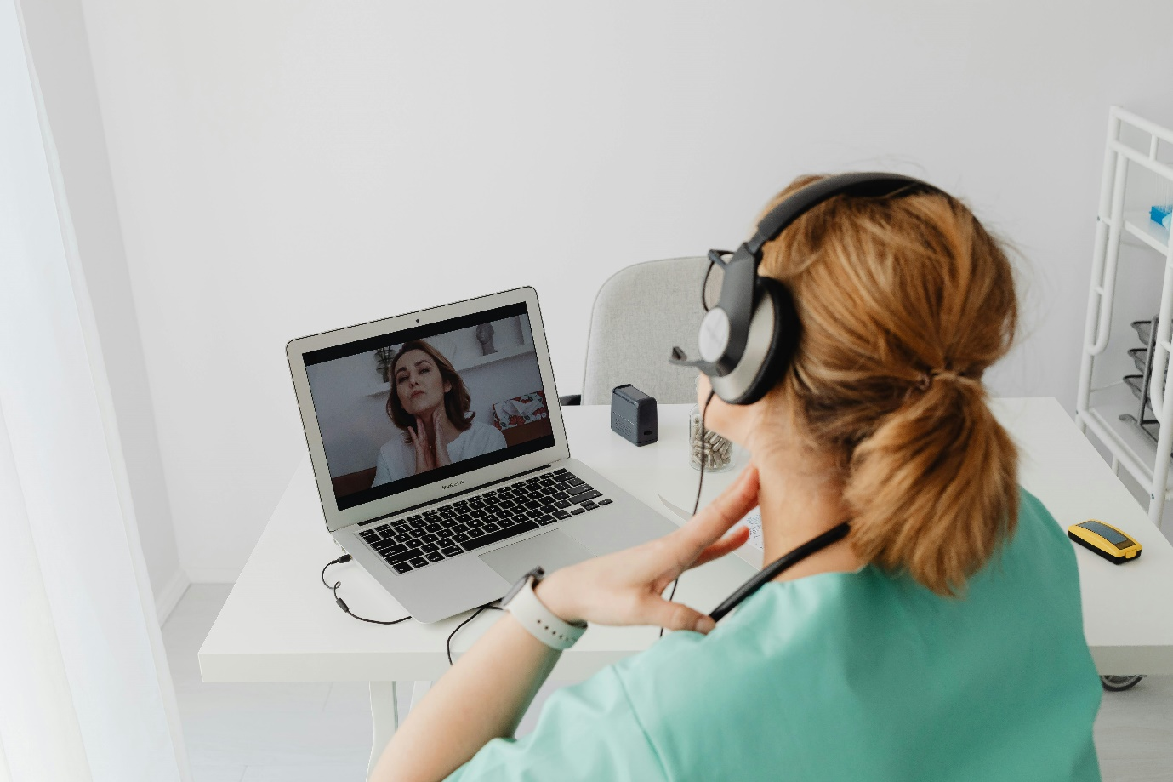

Figure 1: Name of the figure

# **2. Objectives**

# 2.1. General

Lorem Ipsum is simply dummy text of the printing and typesetting industry. Lorem Ipsum has been the industry's standard dummy text ever since the 1500s, when an unknown printer took a galley of type and scrambled it to make a type specimen book. It has survived not only five centuries, but also the leap into electronic typesetting, remaining essentially unchanged. It was popularised in the 1960s with the release of Letraset sheets containing Lorem Ipsum passages, and more recently with desktop publishing software like Aldus PageMaker including versions of Lorem Ipsum.

# 2.2 Specific objectives

|  |  |  |
| --- | --- | --- |
| Title | Title | Title |
| Lorem Ipsum | Lorem Ipsum is simply dummy | Lorem Ipsum is simply dummy |
| Lorem Ipsum | Lorem Ipsum is simply dummy | Lorem Ipsum is simply dummy |
| Lorem Ipsum | Lorem Ipsum is simply dummy | Lorem Ipsum is simply dummy |
| Lorem Ipsum | Lorem Ipsum is simply dummy | Lorem Ipsum is simply dummy |

*Table 1: Name of the table*

**3. Methodology**

# **4. Results**

# **5. Conclusions**

# **6. Annexes**